Bike Shop Optimization: SQL, Excel, Tableau Analysis

By:

**Aryan Sinha (225805186)**

**Shrey Bhardwaj (225805170)**

Dept. Of Computer Science and Engineering (Core)

Manipal Institute of Technology

Table Of Contents

|  |  |  |
| --- | --- | --- |
| **S. no** | **Title** | **Page No:** |
| **1.** | **Introduction (Problem Statement)** |  |
| **2.** | **Abstract** |  |
| **3.** | **Technologies Used** |  |
| **4.** | **Design (ER Diagram)** |  |
| **5.** | **Implementation** |  |
| **6.** | **Testing, Result and Analysis** |  |
| **7.** | **Conclusion** |  |
|  |  |  |
|  |  |  |
|  |  |  |
|  |  |  |
|  |  |  |
|  |  |  |

**Introduction (Problem Statement):**

Bike shop owners lack insights into sales trends, inventory management, and customer preferences, hindering efficient operations and growth. This project aims to analyze data from multiple bike shops using SQL, Excel, and Tableau to uncover actionable insights and improve decision-making processes for optimizing business operations and enhancing customer satisfaction.

**Abstract**

This project employs a multifaceted approach to analyze data from various bike shops, leveraging SQL, Excel, and Tableau. SQL facilitates seamless integration of disparate datasets and enables thorough exploratory analysis, unveiling underlying trends and correlations. Excel serves as a powerful tool for detailed examination of sales patterns and inventory management, extracting valuable insights from the data. Meanwhile, Tableau's intuitive visualization capabilities empower the creation of interactive dashboards, providing stakeholders with a clear and insightful overview of key metrics. Through comprehensive data integration, exploratory analysis, and dashboard development, this project aims to enhance decision-making processes within the cycling industry, driving growth and fostering strategic business development initiatives.

**Technologies used:**

This project harnesses the power of three essential technologies: SQL, Excel, and Tableau, to conduct a comprehensive analysis of multiple bike shops' data. SQL serves as the backbone for integrating disparate datasets and performing exploratory data analysis, allowing us to uncover hidden patterns and correlations within the data. Excel complements this process by providing robust tools for in-depth sales and inventory analysis, enabling us to derive actionable insights from the raw data. Finally, Tableau facilitates the visualization and dashboard creation process, transforming complex data into intuitive visualizations and interactive dashboards. By leveraging these technologies synergistically, we aim to enhance decision-making processes and drive growth within the cycling industry by providing stakeholders with actionable insights and strategic recommendations.

**DESIGN (ER DIAGRAM)**

We've put a lot of thought into how we organize our database, and it's split into two main sections: the Production schema and the Sales schema. Each of these is like a blueprint for how we handle different aspects of our business. The Entity-Relationship (ER) diagram we've included gives you a glimpse into the inner workings of these schemas. It shows how everything connects and interacts, kind of like a map guiding us through our data landscape. The ER diagrams can be found below.   
  
**Production Schema**:

**categories**: (category_id (Primary Key), category_name)

**brands:** (brand_id (Primary Key), brand_name)

**products**: (product_id (Primary Key), product_name, brand_id (Foreign Key referencing brands), category_id (Foreign Key referencing categories), model_year, list_price)

**stocks**: (store_id (Foreign Key referencing sales.stores), product_id (Foreign Key referencing production.products), quantity) 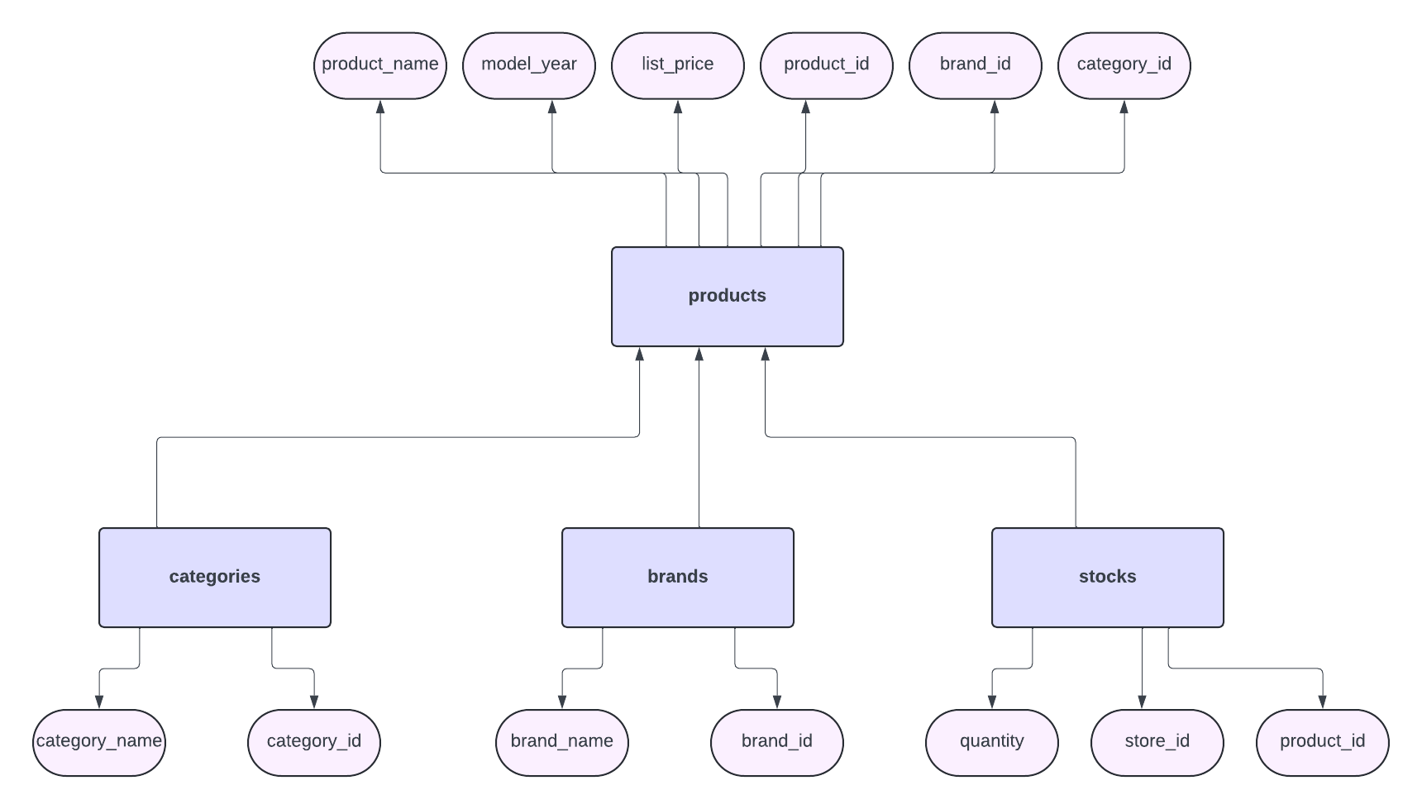

**Sales Schema:**

**customers:** (customer_id (Primary Key), first_name, last_name, phone, email, street, city, state, zip_code)

**stores:** (store_id (Primary Key), store_name, phone, email, street, city, state, zip_code)

**staffs:** (staff_id (Primary Key), first_name, last_name, email, phone, active, store_id (Foreign Key referencing stores), manager_id (Foreign Key referencing staffs))

**orders:** (order_id (Primary Key), customer_id (Foreign Key referencing customers), order_status, order_date, required_date, shipped_date, store_id (Foreign Key referencing stores), staff_id (Foreign Key referencing staffs))

**order_items:** (order_id (Composite Primary Key with item_id), item_id (Composite Primary Key with order_id), product_id (Foreign Key referencing production.products), quantity, list_price, discount)

**IMPLEMENTATION**

1. Data Collection and Storage:

We gathered the data from the bike shops’ database and then stored it in a relational database management system (MySQL).

1. Data Preparation:

The data was cleaned to remove any inconsistencies and errors. Following this, it was transformed into a format suitable for analysis and visualization.

1. SQL Queries:

We had to write SQL queries to extract the required data for our dashboard using various SQL features to manipulate the data.

1. Excel Analysis:

We used Excel as a tool for analysis of the extracted data. We did this by generating pivot tables and creating charts to visualize the various trends.

1. Tableau Visualization:

We then connected Tableau to our Excel file and used it to create visualizations such as bar charts, line graphs and pie charts to represent key metrics. After this we designed the dashboard layout that organizes the visualizations in a clear and concise manner.

1. Dashboard Development:

We built the dashboard in Tableau by dragging and dropping visualizations onto the canvas. We can customize the appearance of the dashboard by adjusting colours, fonts, etc. We also added interactivity to the dashboard such as tooltips, drill-down capabilities, etc.

**Testing, Result and Analysis**

After some thorough testing, the bikeshop sales and orders dashboard proved to be a powerful tool for gaining insights into our business operations. Here are some key findings:

1. Sales Performance:

The dashboard allowed us to track sales and performance over time, revealing trends and patterns in the revenue. Due to this, the resources the resources were allocated in a more efficient way.

1. Product Analysis:

By analysing the product sales data, the top-selling items and underperforming products were identified. This enables us to optimize our product offerings.

1. Customer Insights:

The dashboard provided valuable insights into customer demographics and purchasing behaviour. Due to this, the marketing campaigns and promotions can be tailored more effectively.

1. Regional Analysis:

By geographically mapping sales data, we were able to identify regions with the highest demands for our products.

1. Profitability Analysis:

The dashboard enabled us to conduct profitability analysis by product, customer and sales channel. By understanding which products and customers were driving most profit, we were able to allocate our resources to maximize overall profitability.

Overall, the bikeshop sales and orders dashboard provided actionable insights that helped make informed decisions and drive business growth.